1) dot product

import numpy as np

def create_matrix(mc):

print("\n ARRAY "+str(mc)+"Elements:")

array_1=map(int,input().split())

array_1=np.array(list(array_1))

print("\n ARRAY"+str(mc)+"ROW COLUMN:")

row,column=map(int,input().split())

if(len(array_1)!=(row*column)):

print("\n Row and column size not match with total elements!!retry")

return create_matrix(mc)

array_1=array_1.reshape(row,column)

print("\n ARRAY"+str(mc))

print(array_1)

return array_1

arr1=create_matrix(1)

arr2=create_matrix(2)

if(arr1.shape == arr2.shape):

print("\n Dot product")

print(np.dot(arr1,arr2))

else:

print("\n dimensions not matching!")

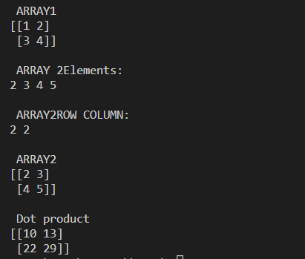

2) Transpose

import numpy as np

def create_matrix(mc):

print("\n ARRAY "+str(mc)+"elements:")

array_1=map(int,input().split())

array_1=np.array(list(array_1))

print("\n array "+str(mc)+",ROWCOLUMN:")

row,column=map(int,input().split())

if(len(array_1)!=(row*column)):

print("\n row and column size not match with total elements!! retry")

return create_matrix(mc)

array_1=array_1.reshape(row,column)

print("\n ARRAY"+str(mc))

print(array_1)

print("\n transpose:")

return (array_1)

print(create_matrix(1).transpose())

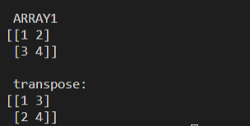

3) feelings

l1=['good','fine','happy','nice','positive']

l2=['bad','frustrated','not','sad','negative']

str1=input('enter your response')

flag=0

ncount=0

pcount=0

t=str1.split()

for i in range(len(t)):

for j in range(len(l1)):

if t[i]==l1[j]:

flag=1

pcount+=1

for k in range(len(l2)):

if t[i]==l2[k]:

flag=1

ncount+=1

if flag==0:

print('you are in another mood')

elif ncount%2==0:

print('positive response')

else:

print('negative response')







4)Rank

import numpy as np

def create_matrix(mc):

print("\n ARRAY "+str(mc)+"elements:")

array_1=map(int,input().split())

array_1=np.array(list(array_1))

print("\n array "+str(mc)+",ROWCOLUMN:")

row,column=map(int,input().split())

if(len(array_1)!=(row*column)):

print("\n row and column size not match with total elements!! retry")

return create_matrix(mc)

array_1=array_1.reshape(row,column)

print("\n ARRAY"+str(mc))

print(array_1)

print("\n Rank:")

return (array_1)

print(np.linalg.matrix_rank(create_matrix(1)))

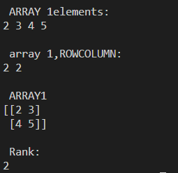

5)KNN

from sklearn.neighbors import KNeighborsClassifier

from sklearn.model_selection import train_test_split

from sklearn.datasets import load_iris

irisdata=load_iris()

x=irisdata.data

y=irisdata.target

x_train,x_test,y_train,y_test=train_test_split(x,y,test_size=0.2,random_state=42)

knn=KNeighborsClassifier(n_neighbors=3)

knn.fit(x_train,y_train)

print(knn.predict(x_test))

print(knn.score(x_test,y_test))

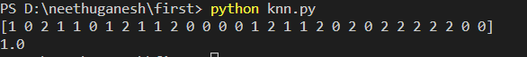

6)KNN 2

from sklearn.neighbors import KNeighborsClassifier

from sklearn.model_selection import train_test_split

x=([1],[2],[3],[4],[5],[6],[7],[8],[9],[10])

y=[1,4,9,16,25,36,49,64,81,100]

x_train,x_test,y_train,y_test=train_test_split(x,y,test_size=0.2,random_state=42)

knn=KNeighborsClassifier(n_neighbors=1)

knn.fit(x_train,y_train)

print(x_test)

print(knn.predict(x_test))

print(knn.score(x_test,y_test))

